Count Frequency of Elements

Problem
Given an array a[] of size n, our task is to find the frequency of each element in the array.

Example
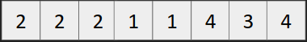
In the above array, frequency of elements is
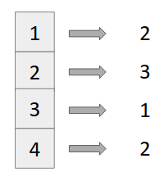
Answer
Steps
- Declare a map (say freq) of both keys and value as int.
map<int,int> freq;
- Iterate over the elements of the array and in each iteration just do,
freq[a[i]]++;

Imagination of freq map should be like this in your mind

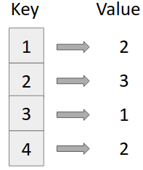
freq map

Code
